INTERNATIONAL STUDENT COURSE REGISTRATION FORM (FOR ATA AND TUR CODE COURSES)

I.TO BE FILLED BY THE STUDENT.

TO THE REGISTRAR’S OFFICE,

I kindly request to be registered to courses listed in the table below.
Kind Regards.

Student’s;
Name Surname: Student Number:
Department/Program: Semester:
Mobile Phone Number: E-mail:
Date: Signature:

CRN | Course Code | Course Name

NOTE: Please do not request course registration for time-conflicting courses.

II. REGISTRAR’S OFFICE
NAME, SURNAME, SIGNATURE, DATE (Course registrations are done.)
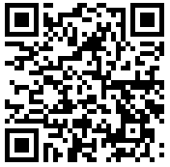
* Registrar's Office processes your personal data limited to the purposes specified in the Law within the scope of the Law No. 6698 on the Protection of Personal Data. You can reach the clarification text on the subject by using the QR code or the link below.
http://www.sis.itu.edu.tr/EN/KVKK/clarification-text.php

